**Color Detector Project**

**From: Divendra Sowamber, Suong Luong & Rutvij Dodiya**

**Discipline: Computer Engineering Technology**

**Date: February 2, 2019**

# Declaration of Joint Authorship

We, Divendra Sowamber, Suong Luong and Rutvij Dodiya confirm that this work submitted for the capstone project is the joint efforts of ourselves, and is expressed in our own words. Any uses made within of other works of any other author, in any form (ideas, concepts, numbers, previous technologies, statistics, programs, texts) are properly acknowledged at the point of use and included from the references list. For the work contribution, Rutvij Dodiya has handled the Database and Coding framework, Kritish Sowamber has handled the sensors with hardware and Suong Luong has handled mobile application aspects of this project.

# Approved Proposal

## Executive Summary

## Background

# Abstract:

The purpose of this report is to provide a detail description for the final capstone project - Color Detector. This project is a combination of hardware and software application components. The hardware is set up with Raspberry Pi and three attached sensors. The software app provides users an interface to interact with the hardware platform. Users will have different selection on the app to retrieve data, view fruit names and conditions(ripe, unripe or ready). It will display the fruits name, fruits conditions based on their color value (hex value). Other information readings include the examining in real-time process such as displaying surrounding temperature, battery-life of the device and location with current timestamp. Based on requirements of this course, this capstone project which is designed to solve real world problem. To be specific, it can be used individually or in farm area where people grow fruit and want to check the progress of fruit ripeness anytime regardless the user location. This helps the users determine the proper time to harvest. For more support, users will be able to check device battery, usage time with statistics and graph. This software also has different languages as well as customizations to help users navigate simply and easily.

**Table of Contents**

Contents

Declaration of Joint Authorship 2

Approved Proposal 3

Executive Summary 3

Background 3

Abstract: 4

1. Introduction 6

2. Project Description 8

2.1 Problem 8

2.2 Rationale Behind Project 8

2.3 Project Scope 8

2.4 Software Requirement Specifications 8

2.4.1 Database 8

2.4.2 Mobile Application 8

2.5 Project Overview 8

2.5.1 Bill of Materials 8

2.5.2 Time Commitment 8

2.5.3 Mechanical Assembly 8

2.5.4 PCB and Soldering 8

2.5.5 Power Up 8

2.5.6 Unit Testing 8

2.5.7 Production Testing 8

3. Progress Reports 8

3.1 Report 1 8

3.2 Report 2 8

3.3 Report 3 9

4. Conclusions 9

5. Recommendations 9

6. Technical References 9

7. Appendicies 9

# Introduction

This capstone project (Color Detector) is based on assigned sensors from CENG317 Course (TCS34725 Color Sensor , TMP007 Temperature Sensor, ADS1115 16-Bit ADC- 4 Channel Sensor). The core function of this project is to determine fruit ripeness from the color value based on the color sensor. This software application works with hardware platform and could be set up in one location while the user can control the device remotely from another location. To have access to the app, the users must login or register an account using an valid email address and password. After login, the users will have different options to retrieve the data in offline mode or real-time in online mode. While the hardware device is running, it will keep pushing data such as temperature in the current environment, battery remaining to operate, and the color value of the fruit to the database. Both hardware and software work with Firebase mobile platform to store and retrieve data.

# 2. Project Description

## 2.1 Problem

## 2.2 Rationale Behind Project

## 2.3 Project Scope

## 2.4 Software Requirement Specifications

### 2.4.1 Database

### 2.4.2 Mobile Application

## 2.5 Project Overview

### 2.5.1 Bill of Materials

### 2.5.2 Time Commitment

### 2.5.3 Mechanical Assembly

### 2.5.4 PCB and Soldering

### 2.5.5 Power Up

### 2.5.6 Unit Testing

### 2.5.7 Production Testing

## 

## 3. Progress Reports

### 3.1 Report 1

|  |  |  |  |  |
| --- | --- | --- | --- | --- |
| |  | | --- | | Suong Luong <luongkingsley@gmail.com> | | Fri, 1 Feb, 13:24 |  | https://mail.google.com/mail/u/0/images/cleardot.gif  https://mail.google.com/mail/u/0/images/cleardot.gif |
| |  | | --- | | to austin.tian@humber.ca  https://mail.google.com/mail/u/0/images/cleardot.gif | | |  |

The purpose of this report is to provide information about current project status - Color Detector

**I. Hardware:**

The hardware is properly assembled now. All three sensors (Color Sensor TCS34725, Temperature Sensor TMP007, ADS1115 16-Bit ADC) are properly assembled on the same PCB. The address for each sensor is also tested. In conclusion, the hardware is fully functional and in good condition. It is connected to Firebase platform for pushing data later.

**II. Software:**

The layout for all the activities need to be designed to have the same theme and font. The software is also connected to Firebase platform to retrieve database. Things may be changed in the next couple weeks for the condition codes when real-time data are stored.

**III. Problems and Resources:**

Currently, the coding part and stored data for this project need to be completed. RGB range value to store on Firebase are considered.

*Github websites:* <https://github.com/SuongLuong/CapstoneProject>

*References:*

<http://bradsrpi.blogspot.com/2013/05/tcs34725-rgb-color-sensor-raspberry-pi.html>

hps://[www.rapidtables.com/web/color/RGB_Color.html](http://www.rapidtables.com/web/color/RGB_Color.html)

<https://medium.com/@dvd.ciri/raspberry-pi-firebase-home-automation-d5a237f18fb5>

**IV. Financial update:**

The cost for this project includes sensors, solar panels, header pins, PCB, Raspberry Pi 3 B+. Most of the parts are provided by Humber Prototype Lab. The total cost for others( Raspberry Pi, sensors, solar panels): $188.08

In the future, some additional parts such as: screen for Raspberry Pi may be considered.

**V. Contribution**

All team members are working together for PCB and for each sensor, different codes will be combined for different readings.

Sincerely,

Kingsley Luong

https://ssl.gstatic.com/ui/v1/icons/mail/images/cleardot.gif

### Report 2

The purpose of this report is to provide information about our current project status until now (Week 6) - Color Detector

**I. Hardware:**

The hardware is fully assembled now. All three sensors (Color Sensor TCS34725, Temperature Sensor TMP007, ADS1115 16-Bit ADC) are properly assembled on the same PCB. The codes for three sensors have also been merged into one program and tested. In conclusion, the hardware is fully functional and in good condition for further development. It is also connected to Firebase platform to store data with three field: Hex values for Color, Temperature values in Celsius and Voltage charges.

**II. Software:**

The overall design of the software application is completed. The software is also connected to Firebase platform to retrieve database. At this time, the condition codes for fruit name and color ranges are planned to compare with real-time data from hardware.

**III. Problems and Resources:**

Currently, the coding part and stored data for this project has been implemented. RGB range values to store on Firebase and the conditions from software need to be matched.  Approximations need to be tested more because the color readings still varies. Several testings were conducted by placing an object in front of the color sensor, we noticed the readings and compared it in the color picker and we could see that the hex value was matching. While merging the code, we were also facing problem with indentation as the code is in Python.

**Github websites:** <https://github.com/SuongLuong/CapstoneProject>

**References:**

<http://bradsrpi.blogspot.com/2013/05/tcs34725-rgb-color-sensor-raspberry-pi.html>

hps://[www.rapidtables.com/web/color/RGB_Color.html](http://www.rapidtables.com/web/color/RGB_Color.html)

<https://medium.com/@dvd.ciri/raspberry-pi-firebase-home-automation-d5a237f18fb5>

<https://discuss.codecademy.com/t/suggestion-for-the-rgb-to-hex-project/79009>

**IV. Financial update:**

Remaining the same. The cost for this project includes sensors, solar panels, header pins, PCB, Raspberry Pi 3 B+. Most of the parts were provided by Humber Prototype Lab. The total cost for the main components(Raspberry Pi, sensors, solar panels): $188.08

In the future, some additional parts such as: screen for Raspberry Pi may be considered.

**V. Contribution**

We work together.

Sincerely,

Divendra Sowamber

### Report 3

The purpose of this report is to provide information about the most updated project status until Week 9.

**I. Hardware:**

By this time, there were no necessary changes required on hardware.

(The hardware is fully assembled now. All three sensors (Color Sensor TCS34725, Temperature Sensor TMP007, ADS1115 16-Bit ADC) are properly assembled on the same PCB. The codes for three sensors have also been merged into one program and tested. In conclusion, the hardware is fully functional and in good condition for further development. It is also connected to Firebase platform to store data with three field: Hex values for Color, Temperature values in Celsius and Voltage charges.)

**II. Software:**

The overall design of the software application is completed. The software is also connected to Firebase platform to retrieve database. At this time, the condition codes for fruit names and color ranges are implemented on the software side to test with real-time data from hardware.

**III. Problems and Resources:**

Currently, the coding part and stored data for this project has been implemented. However, while placing any objects nearby the sensor, the result did not match the correct color value. Two hex values from the object and the color wheel are different. The reason may be caused by noise from the object.

*Github websites:* <https://github.com/SuongLuong/CapstoneProject>

*References:*

[*https://www.sessions.edu/color-calculator*](https://www.sessions.edu/color-calculator)

<http://bradsrpi.blogspot.com/2013/05/tcs34725-rgb-color-sensor-raspberry-pi.html>

<https://medium.com/@dvd.ciri/raspberry-pi-firebase-home-automation-d5a237f18fb5>

<https://discuss.codecademy.com/t/suggestion-for-the-rgb-to-hex-project/79009>

**IV. Financial update:**

Remaining the same. The cost for this project includes sensors, solar panels, header pins, PCB, Raspberry Pi 3 B+. Most of the parts were provided by Humber Prototype Lab. The total cost for the main components(Raspberry Pi, sensors, solar panels): $188.08

In the future, some additional parts such as: screen for Raspberry Pi may be considered.

**V. Contribution**

All team members worked together for PCB and for each sensor, different codes were combined already. In the next couple weeks, the final report and demonstration must be ready.

Sincerely,

Rutvij Dodiya

## **4**. Build Instruction

### **4.1 Items (Shipping fee included):**

* Raspberry Pi - $112
* Color Sensor TCS34725 - $15
* Temperature Sensor TMP007 - $36
* ADS1115 16-Bit ADC - $8
* Solar panel - $15
* Pi cobbler - $20

Total Cost - $206

The following components are provided by the Prototype Lab:

* Printed Circuit Board
* Connectors
* Header Pins
* Soldering equipment

### **4.2 Schedule:**

**PCB Design:**

By testing the circuit in advance on breadboard and using Fritzing tool, it will take about 1 day to design and 3 days to get PCB printed from the Prototype Lab.

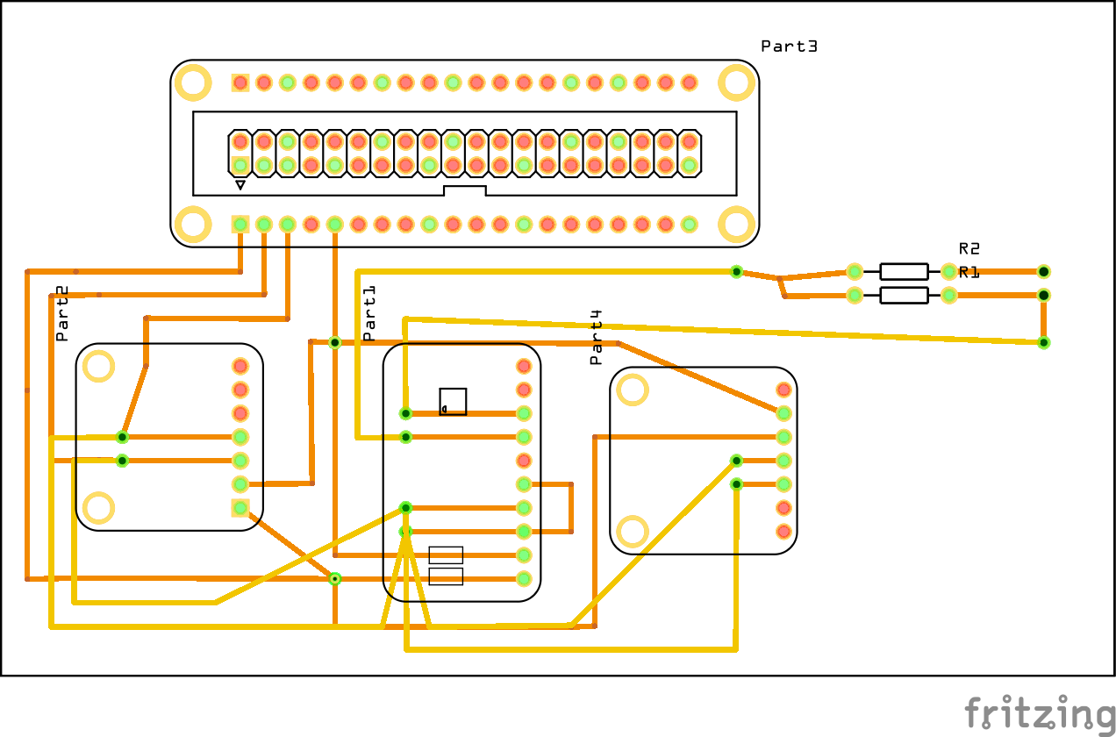

**Soldering, RPI Connection and Enclosure**

Approximately 2 hours to de-solder and solder all parts into one component

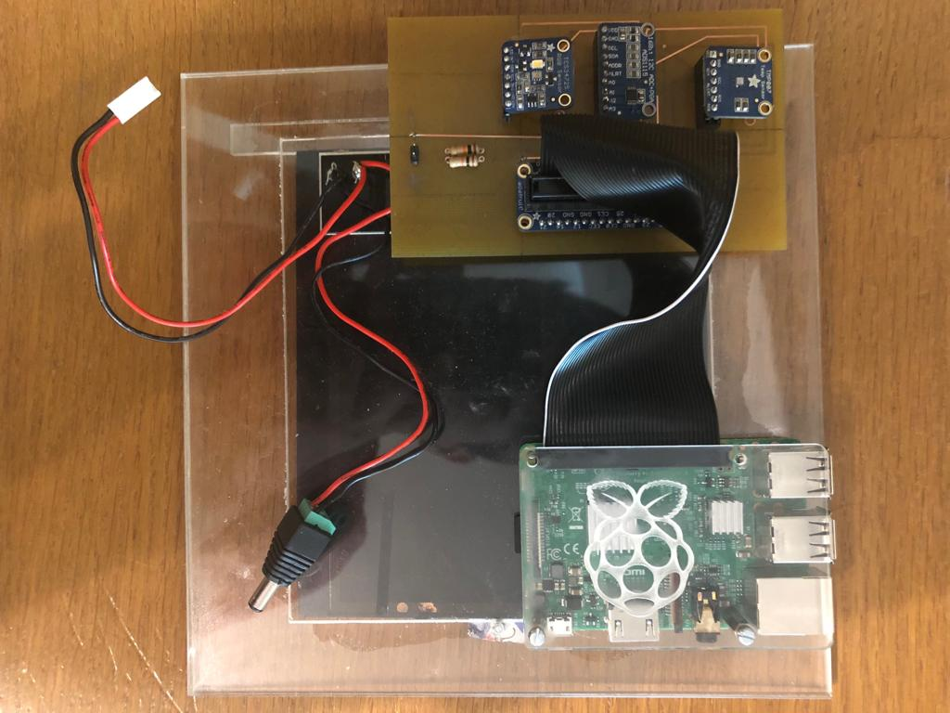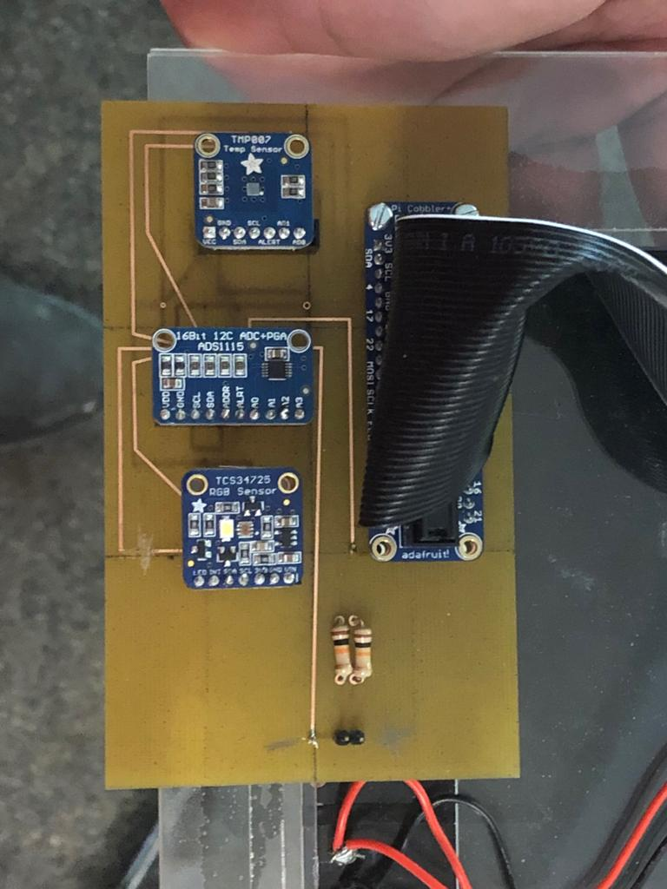

**Total time:** It will take up 4 to 5 days to complete the hardware.

### **4.3 Database set up and the structure of the database**

To set up the Firebase database, python library is installed on both hardware and software.

Based on the sensors, there are 3 main data types to store on Firebase: color hex value, temperature value and voltage value. Other data such as timestamps, fruit names are also added to keep track on the latest value from the sensor. Below is a diagram of the data structure.

The main node represents the User ID and nodes under it represents data that keeps on updating.

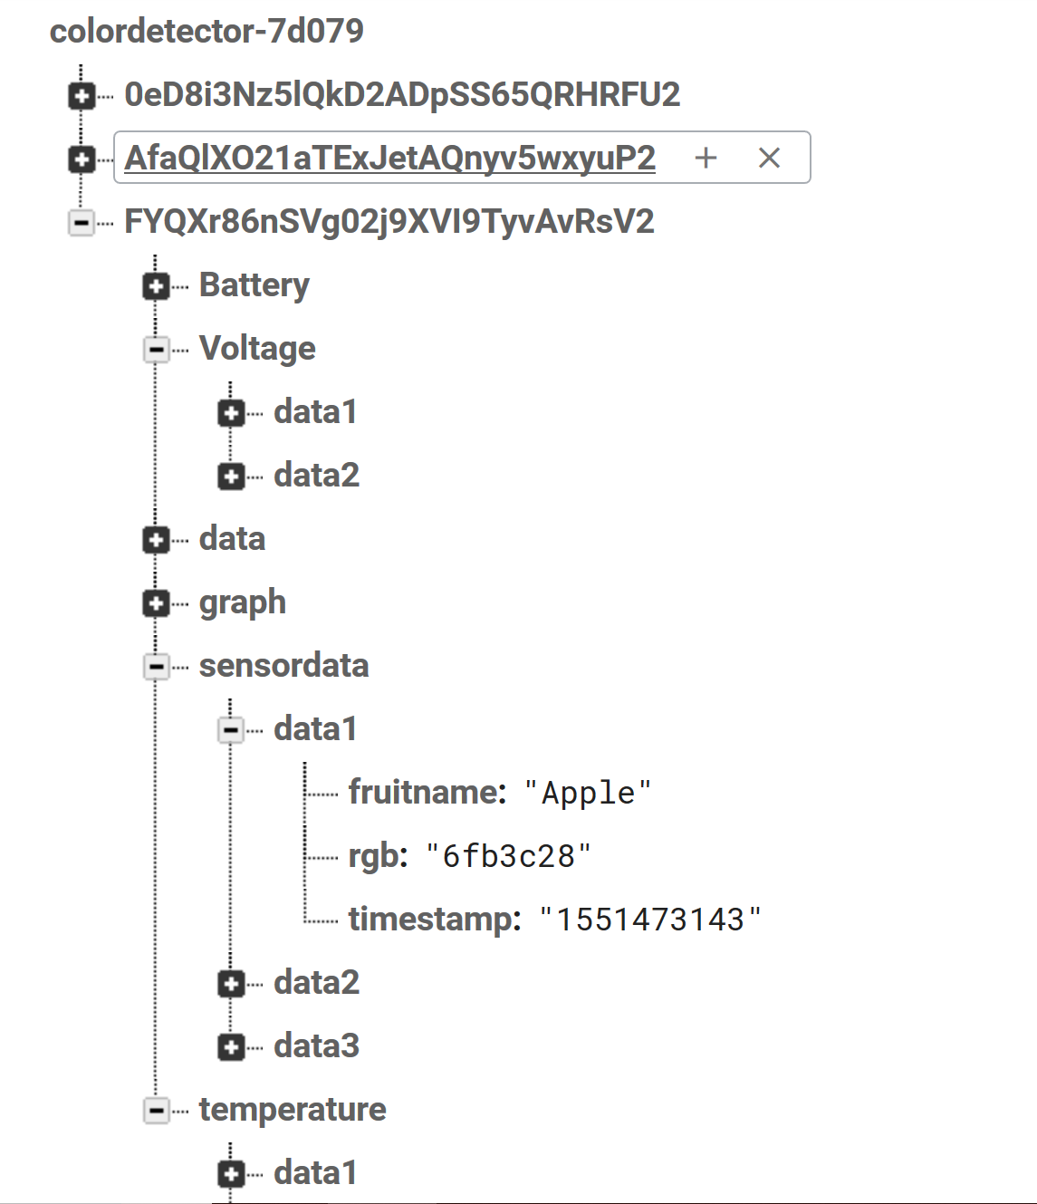

Data structure

### **4.4 The configuration of the hardware and software, including your PI and the database:**

Hardware: Install python library to communicate with Firebase database and installed on the raspberry pi.

To connect with computer, network sharing must be turned on so that the Raspberry Pi can be recognized and be able to access the internet. (Retrieved from <https://pypi.org/project/python-firebase/>)

Software: Install Firebase SDK and set up real time-database on the Firebase platform website. (Retrieved from: <https://firebase.google.com/docs/android/setup>)

### **4.5 The Android APP building instructions and compiling, running environments.**

Android Studio IDE is used for “compiling and running environment” to create the application. The application is then installed on android smartphone and data would be synchronized between the app and the database.

Firebase is also used as Real-time database platform for the application and hardware to store data.

#### 4.5.1 Introduction

This project (Color Detector) is based on assigned sensors from Ceng317 course (color sensor Tcs34725, Tmp007 Temperature Sensor, ADS1115 16-Bit ADC- 4 Channel sensor). The core function of this project is to determine fruit ripeness from the color value based on the color sensor. This software application works with hardware platform which is a portable device and could be set up in one location while the user can control the device remotely from another location. To start the app, the users must login or register an account using an valid email address and password. After login, the users will have different options to retrieve the data in offline mode or real-time in online mode. While the device is running, it will keep sending data such as temperature in the current environment, battery remaining to operate, and the color value of the fruit to the database.

#### 4.5.2 Design and Data

The “Portable Color Detection Device” software is a mobile application which get the information from hardware to measure fruits ripeness. Based on the colors of the fruits, people can test them on the tree if they are ready to pick or not without destroying the fruit. By using the software, people can keep track of fruit processes and access other observations online.

##### 4.5.2.1 Android components:

Main components used in this project:

* TextView
* Button
* ImageView
* NavigationBar
* Launcher/Splash Screen

##### 4.5.2.2 Data structure:

 The data structure for this project consists of 7 variables as follow:

1. “temp” holds data of temperature
2. “bat” stands for battery which holds data of battery
3. “volt” which serves for voltage data derived from battery
4. “charge” helps to hold data while battery is under charge mode
5. “fruitname” holds data of various fruits such as apple, banana, strawberry, blueberry, orange (in this case and later for the next semester, more fruits will be added in our database)
6. “rgb” which shows color value in our database in terms of hexadecimal value
7. “timestamp” which holds data based on epoch time which displays the value in format of Year,Month,Day,Hour,Minutes,Seconds to track the data in terms of current time.

Most of the data is retrieved from the database (Firebase) in the app. This means the data is fetched directly from database. For next semester, real data will be pushed directly from the hardware device every time the users do the scan. The only data which is written from the app to the database is login and registration information where the data is pushed in authentication section of the database.

#### 4.5.3 References:

* Helpful references used in this project
* Powerpoint resources on Blackboard
* Android developer website: <https://developer.android.com/>
* Github course website from Professor: <https://github.com/AustinCENG>
* <http://angrytools.com/android/button/>

### **4.6 Project testing:**

In real situation, the hardware is powered on and connected to computer through an Ethernet cable and the user can access the command prompt interface over the network. To test all the sensors, python program needs to be run then the sensors will send reading data to Firebase( color hex, temperature, voltage values should be pushed into database in real time). In case it does not run as expected, run the “sudo i2cdetect -y 1” to check if all three addresses are present.

All the connections must be accurate and secured. The data will be pushed into Firebase. In the app, users will retrieved the data from Firebase. Based on these value and the condition, the app will determine the status of the fruits.

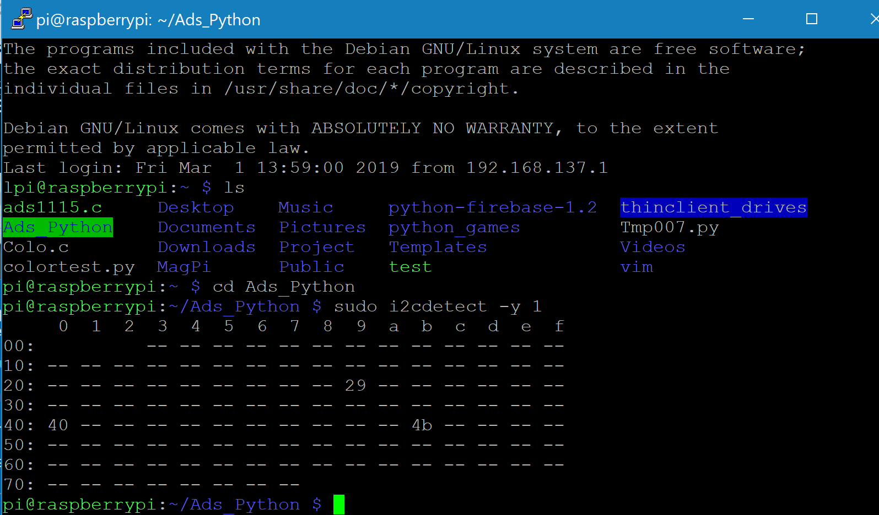

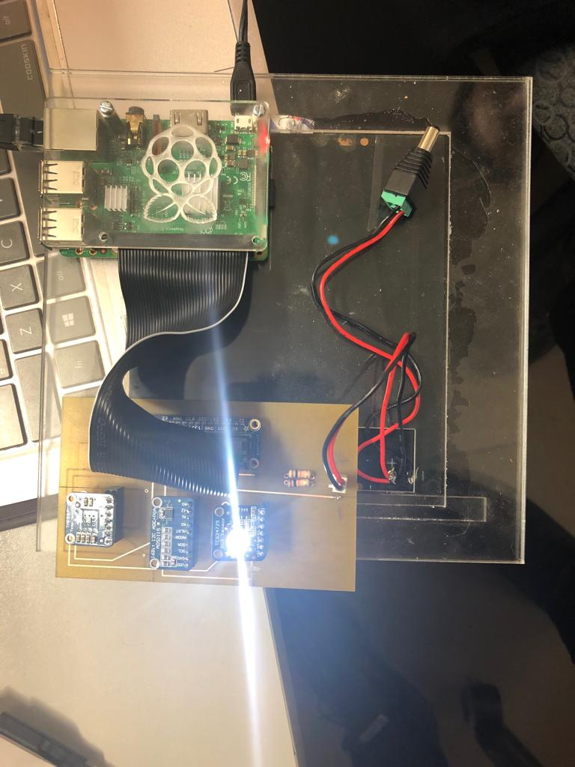

### **4.7 References:**

<https://firebase.google.com/docs/android/setup>

<https://pypi.org/project/python-firebase/>

<https://developer.android.com/studio>

## 5. Conclusions

## 6. Recommendations

## 7. Technical References

## 8. Appendicies